JOINT POSITION STATEMENT & RESEARCH REPORT ON DISABILITY & HIGHER EDUCATION

Acknowledgements

ALSA, AMSA, & NUS represent three peak bodies within higher education. We strive to empower individual voices, such as those belonging to disabled students, across Australia’s tertiary education sector. We strive to empower individual voices, such as those belonging to disabled students, across Australia’s tertiary education sector.

We would like to thank the organisations and individuals, including — inter alia — Maddy Ransley, Justine Hu, Dr Neera Jain, Dr Dinesh Palipana, Mali Hermans, Khanh Tran, Carolyn Frohmader, Grace Wallman, Eva Midtgaard, Jasmine Davis, Jimmy Jan, and Dane Luo, who contributed their insights, feedback, case studies, and personal stories to assist in the drafting and creation of this report.

ALSA, AMSA, & NUS represent three peak bodies within higher education. We strive to empower individual voices, such as those belonging to disabled students, across Australia’s tertiary education sector.

Report Author:
- AW Shim — Australian Law Students’ Association (‘ALSA’), in consultation and coordination with disabled students & disabled student representatives.

Language:
- ALSA, AMSA, & NUS, chose to use a mix of person-first and identity-first language (“person with disability” and “disabled person” respectively) throughout this research paper to reflect author preference in the disability community. Likewise, we use d/Deaf — as well as autistic and Autistic — to reflect varying preferences among disabled individuals and to reflect not only the lived experience but also their identities.

Media Contacts

Presidents:
Georgie Beatty | president@nus.asn.au | +61 411 606 808 | https://nus.asn.au
Annabel Biscotto | president@alsa.asn.au | +61 400 206 011 | https://alsa.asn.au

[page break]
Introduction

We — as peak bodies and representative organisations within Australia’s higher education sector — write on behalf of the below signatories and endorsing organisations to seek urgent reform to not only anti-discrimination legislation such as the Disability Discrimination Act 1992 (Cth) (‘DDA’) and subordinate legislation such as the Disability Standards for Education 2005 (Cth) (‘DSE’) but also the higher education sector at large.

Recognising the systemic neglect experienced by disabled students and disabled staff (including disabled academics), w, we call for strong action by the higher education sector — including from universities and regulatory bodies such as the Tertiary Education Quality and Standards Agency (‘TEQSA’) and the Australian Skills Quality Authority (‘ASQA’) — to promote equal access to education and non-discrimination for people with disabilities.

- Disability Discrimination within Higher Education

The United Nations Convention on the Rights of Persons with Disabilities (‘CRPD’) requires state parties to safeguard the rights of people with disability to equality, liberty, and personal integrity, which includes a right to protection from discrimination. Article 24, for example, declares that signatory states — including Australia — ‘shall enable persons with disabilities to learn life and social development skills to facilitate their full and equal participation in education and as members of the community’, and that states ‘shall ensure persons with disabilities are able to access general tertiary education, vocational training, adult education and lifelong learning without discrimination and on an equal basis with others’. Furthermore, the CRPD enshrines ‘the right of persons with disabilities to work, on an equal basis with others’ in article 27.

Non-discrimination protections under both of these articles are articulated in article 5, which requires state parties to ‘prohibit all discrimination on the basis of disability and guarantee to persons with disabilities equal and effective legal protection against discrimination on all grounds’. Due to the historical inequities such as ‘the unequal and discriminatory application of the law’ towards disabled people, disability discrimination and legal prohibitions against it, through article 5 of the CRPD, are of significant interest from a human rights perspective.

Internationally, the systemic exclusion of disabled students and disabled academics is strongly correlated with disability discrimination — also known as ableism. Domestically, ableism in the higher education sector can manifest as systemic biases and inequitable service provisions. Described within Australia as ‘ableist ivory towers’, higher education institutions which neither acknowledge ableism and systemic biases nor undertake positive action to redress ableism may infringe the aforementioned CRPD articles by failing to prohibit discriminatory practices, particularly against those with invisible disabilities, intellectual disabilities, cognitive impairment, and psychosocial disabilities.

Unfortunately, inaction towards remedying systemic ableism pervades sector-wide. Despite Australia’s CRPD obligations, people with disabilities in Australia are significantly less likely to go to university. In addition, disabled students are more likely to rate their university experience lower than their peers, and they are more likely to drop out of university. Concerningly, only 17% of Australians with a disability have a Bachelor’s degree or higher, as compared to 35% of Australians without a disability.

Moreover, there is great concern that those who attempt to study at university lack the support and resources to do so, regardless of the prestige and value proposition of their university. Alarmingly, the Group of 8 (‘Go8’) universities — despite their ‘accumulation of academic, cultural and socioeconomic capital’, representing the acme for tertiary education in Australia — are excluding disabled students at higher rates than the sector average. Similarly, disabled academics — particularly those with psychosocial disabilities, neurodivergent conditions, and invisible disabilities — report adverse experiences at Go8 universities and other ostensibly prestigious universities.

Although Go8 universities have been recruiting and enrolling more disabled students in absolute numbers, they are underperforming in their equity parity targets, as exemplified by the low levels of proportional educational completions of disabled students at Go8 universities. Indeed, proportional underrepresentation of disabled students at Go8 universities, alongside the comparative overrepresentation of disabled students at non-Go8 universities, intimates a stratification of social disadvantage for disabled students — particularly in ‘universities and courses with the most competitive entry requirements’, such as law and medicine.

The condensation of systemic ableism within prestigious courses also co-occurs with adverse findings regarding attitudes towards psychosocial disabilities within the legal sector, with more than 60% of law students and 50% of solicitors reporting fears of discrimination if they experience depression. For barristers, depression (at 37.1%) and suicide or self-harm (at 11.3%) are frequently cited as main causes of death or disability, and yet a ‘substantial’ proportion of the legal sector are reported as holding negative views about depressed people. Because elite universities are ‘are uniquely placed to alleviate issues around social mobility’, improving diversity, equity, and inclusion (‘DE&I’) — including regarding disability and ableism — within the proverbial ivory towers remains important.

Despite the urgent need to address ableism within higher education, progress remains stagnant. This trend especially applies for those from First Nations, culturally and linguistically diverse (‘CALD’), and other intersectional, minoritised, and marginalised backgrounds, thereby belying the ‘egalitarian social justice imprimatur of expanded access [in higher education]”. Disabled students are consistently showing lower rates of success and social inclusion, which confirms the literature pointing to the poor implementation of participatory and co-production approaches to policy development for disabled students.

As contributory factors to inequitable outcomes experienced by disabled students, inconsistent and inflexible approaches to policy, practice, and reasonable adjustments are prevalent in the higher education sector, with ‘administrative processes’ and ‘attitudes of teaching staff’ commonly cited as systemic barriers. Indeed, disabled students — as well as disabled staff — are reportedly receiving inadequate funding, attention, and due care with regards to the reasonable adjustments & accommodations which they require, with gaps in coordination and poor understanding of people with disability highlighted as thematic issues. Although the Disability Standards for Education 2005 (Cth) (‘DSE’) are supposed to prevent disability discrimination in education, mandating of the DSE and implementation thereof have been inconsistent and ‘not well understood by education providers’.

This lack of understanding only compounds from the power imbalances between disabled students and educational providers. Currently under the DSE and the DDA, educational providers may ‘seek advice from their own expert staff… as to the kinds of adjustments that could and should be made’, with the court determining that the teachers, rather than the disabled student and the advice of the student’s supports, would be the best positioned to determine which adjustment should be implemented. When educational providers and administrators can act as arbiters who understand a disabled person’s lived experience more than the disabled person and their treating team, ableist assumptions and faculty attitudes can directly impact the permanence and success of disabled students.

Furthermore, many educational providers have neither undertaken critical disability training and anti-ableist training nor invested in training to develop a ‘disability consciousness’ among higher education staff, despite the articulated shortcomings of current disability competence training. Although resources such as the National Disability Coordination Officer (‘NDCO’) Program exist, they are inadequately funded and implemented, further exacerbated by the lack of a Disability Education Commissioner to enforce and monitor the implementation of the DSE and disability policies to destigmatise disability. At significant rates, hidden disability and concomitant stigma are negatively impacting disabled students’ interactions with peer and teaching staff, reflecting the ‘historically ableist culture of universities’.

In attempting to access higher education, disabled students continue to face barriers that are both attitudinal and architectural insofar as they are features built into institutions. Submissions to the Royal Commission into Violence, Abuse, Neglect and Exploitation of People with Disability (‘Disability Royal Commission’) describe these barriers as ‘structural and systemic’ in nature, including a ‘lack of adequate awareness and capacity in educational institutes to understand and accommodate the needs of students with disability’. Moreover, ableist attitudes and approaches to reasonable accommodations affect disabled students during both education and post-education employment. Disability discrimination, in fact, necessitates urgent discussion: 44% of complaints received by the Australian Human Rights Commission (‘AHRC’) are about disability discrimination, with 1 in 6 disabled Australians experiencing disability discrimination in the given calendar year.

Although legal recourse against disability discrimination — via the AHRC — exists in theory, the availability of legal protections and legal remedy remains illusory in practice. When disabled students seek to establish a finding of disability discrimination, they face what People With Disability Australia (‘PWDA’) and Australian Lawyers for Human Rights (‘ALHR’) deem ‘an insurmountable barrier’. The decision in Sklavos v Australasian College of Dermatologists (‘Sklavos’) limits the positive obligation on duty holders — like schools, universities, or workplaces — to make reasonable adjustments and accommodations.

This decision, in effect, raises the threshold for proving a breach of the DDA insofar as disabled students and disabled academics must now prove that a ‘causal link’ exists between their disability and the duty holder’s refusal to provide an adjustment. Without a direct statement from a duty holder specifying that their refusal to accommodate is due to the person’s disability, disabled students and disabled academics have faced — and continue to face — onerous and difficult burdens of proof, thereby curtailing their odds of legal redress and ‘significantly limit[ing] the effectiveness of… the DDA’.

To date, substantive reform to the laws protecting disabled Australians has yet to occur. Post-Sklavos, material and legislative leadership is urgently required in order to better protect people with disability, who have historically been targeted — and continue to be targeted — for abuse and violence. Adopting ‘anti-vilification laws on the basis of disability… [could] demonstrate leadership in this area’. However, disability vilification laws and other such post-Sklavos reforms — within the DDA or state-based disability discrimination laws — do not appear to exist outside of Tasmania, despite recommendations from the Disability Discrimination Legal Service (‘DDLS’) to implement legislative prohibitions against disability vilification. Consequently, disabled academics and especially disabled students across Australia remain vulnerable to discrimination without equitable access to legal redress.

Indeed, Purvis v New South Wales (‘Purvis’), as well as previous cases such as Varasdi v State of Victoria (‘Varasdi’), Sievwright v State of Victoria (‘Sievwright’), and Chung v University of Sydney (‘Chung’), repudiate nation-wide the notion that the DDA in any sense ‘requires or obliges a duty-bearer to accommodate a disabled person’s differences’. Instead of espousing a social, cultural, and human rights model of disability, Australia’s current approach to disability discrimination law fails to conceptualise or ‘understand the duty [to provide reasonable adjustments and accommodations] as a positive obligation with an underpinning right to substantive equality’. Australia’s limiting approach contrasts with the broader approaches of international jurisdictions such as Canada and the United Kingdom, illuminating Australia’s poor ranking among OECD countries for the treatment and life outcomes of disabled people.

Raising Australia’s compliance with the CRPD to recommended levels necessitates substantive reform of not only the DDA but also disability legislation in general, including the National Disability Insurance Scheme Act 2013 (Cth). Notably, the lack of an explicit espousal of the right to substantive equality and the social, cultural, and human rights model of disability impacts disabled students with psychosocial disabilities and Lived Experience with mental ill health, for Australian courts frequently attribute any curtailing of academic performance to the complainant’s psychiatric symptoms rather than to the education provider’s actions — or lack thereof.

Furthermore, a prima facie examination of the AHRC’s Register of Disability Discrimination Act Action Plans indicates that the majority of Table A provider universities — many of whom are Go8 universities — have not as of July 2022 maintained currently active registration, despite receiving Commonwealth funds from the Higher Education Disability Support Program (‘HE DSP’). This implication raises significant concerns regarding the systemic neglect of disabled people and substantiates the urgent need for legislative reform. In fact, the inflexibility by higher education stakeholders, such as external accreditation bodies and educators themselves, are contributing to poor visibility of human rights obligations to disabled students — which demonstrate the failure of the DSE (and implementation thereof) as well as the need for legal accountability.

- Recommendation 1.1: Stakeholder organisations, including universities, should endorse the PWDA letter to the Attorney-General and to support this request for the current Parliament to action urgent reform of the Disability Discrimination Act 1992 (Cth).

- Recommendation 1.2: Stakeholder organisations, including universities, should recommend the Australian Government to implement reform of disability-related legislation and infrastructure which aligns more with the UN CRPD, the human rights model of disability, and the right to substantive equality. This includes implementing the recommendations in the UN CRPD Committee’s 2019 Concluding Observations, such as addressing and prohibiting systemic, intersectional and multiple forms of discrimination.

- Recommendation 1.3: Stakeholder organisations, including universities, should endorse Recommendation 13 of the DDLS Submission to Senate Select Committee on Autism, which calls upon legislative bodies to amend — by espousing a similar approach to that adopted under the Racial Discrimination Act 1975 (Cth) — the DDA and state-based disability discrimination laws to include a prohibition against vilification on the basis of disability.

- Recommendation 1.4: Universities should maintain an active and current registration with the AHRC’s Register of Disability Discrimination Act Action Plans, especially if they are current recipients of HE DSP funding from DESE.

- Recommendation 1.5: Stakeholder organisations, including universities, should endorse Recommendations 1, 2, 3 of the NCSEHE Discussion Paper on the Disability Standards for Education 2005, including the recommendation for the establishment of a Disability Education Commissioner in order to actualise accountability for the implementation of the DDA and DSE within higher education.

- Disability Supports by Universities

Education delivery is another matter which can adversely affect not only disabled students but also students from other under-represented backgrounds — such as First Nations students, LGBTQIA+ students, and those with family, carer, and/or work responsibilities. Moreover, the stratifying and stymying impacts of education delivery — as is currently seen within Australia — can compound for people with intersectional identities, including d/Deaf women, Autistic immigrants from CALD families, and disabled students from First Nations communities.

​​In the aftermath of the COVID-19 pandemic, targeted support attuned to students’ individual needs is essential. Due to the inaccessibility of built environments, attitudinal barriers, and exclusionary decision-making by policy makers, disasters and pandemics can not only exacerbate the ableist discrimination but also kill or injure people with disability at a disproportionately higher rate. Furthermore, the increased use of restrictive practices during emergencies, as spotlighted by the Disability Royal Commission, compounds established concerns regarding the exclusionary educational experience of disabled students and ‘the lower safeguards available to disabled people… in schools’.

This need for tailored, inclusive, and accessible support mechanisms in the context of COVID-19 is particularly pertinent for LGBTQIA+ students, with a 2022 research report from the National Centre for Student Equity in Higher Education (‘NCSEHE’) noting the neglect experienced by LGBTQIA+ populations during disaster responses. These issues with inequitable access to education are of particular concern for disabled students from intersectional and minoritised backgrounds. In fact, the 2022 NCSEHE report confirms that not only disabled students but also international students face ‘particularly high barriers to learning’ during COVID-19, citing a lack of learning accommodations, support resources, and flexibility in scheduling classes.

Educators who are ‘unwilling or unable to provide… content due to lack of preparation or training’, alongside inflexibility with deadlines and grading, also signify notable barriers to accessing learning. Due to the high thresholds of the DDA, the access of disabled students to equitable education is inconsistent. Undergirded by its repudiation of a ‘one-size-fits-all’ approach, Universal Design (‘UD’) — specifically, Universal Design for Learning (‘UDL’) — is research-backed as a pedagogy and a curriculum framework, facilitating equitable access to education for all students — including disabled students and other students from diverse, minoritised backgrounds. Indeed, the NCSEHE has previously recommended mandatory disability competency training and the implementation of UDL. For disabled students, implementing UDL would ostensibly ensure that they can ‘engage with the curriculum without having to seek adjustments’.

The variable application of UDL across the higher education sector can constrict disabled students’ access to optimal supports, regardless of the implementation of adjustments. Because the intersection of attendance requirements and inaccessible built environments can stymie equitable access, applying UDL principles to built environments, as well as to curriculum reform, could decrease student dissatisfaction and systemic non-compliance with the DDA. Furthermore, an open curriculum — an Arts curriculum, similar to that seen at Amherst College and Brown College, without distribution requirements and core curriculum — can increase student engagement, particularly for disabled students from marginalised backgrounds, through curricular co-creation, pedagogical flexibility, and institutional accessibility. Indeed, applying UD principles of increased accessibility, flexibility, and inclusivity — built upon co-design, co-production and co-creation, rather than mere consultation — can optimise engagement beyond tokenism, regardless of accommodations and adjustments.

However, actualising equity requires educational flexibility and attitudinal shifts. Currently, a significant proportion of disabled students report, on account of their institution’s failure to implement UDL, ‘very low levels of satisfaction with the support they receive’. Furthermore, many stakeholders, including those at Go8 universities, appear to consider the notion of a truly open curriculum — similar to that of Amherst, Smith, or Brown wherein undergraduate Arts students can propose a bespoke, multidisciplinary major and sequence of courses within the liberal arts, thereby eschewing the inflexibility compounded by core curriculum and course cuts — to be novel rather than co-producing, notwithstanding accusations that the tertiary education system may no longer be ‘fit-for-purpose’.

In fact, higher education stakeholders — including those involved in accreditation — are yet to embrace a ‘major philosophical shift’ towards flexible assessments, despite the finding that assessment flexibility enhances inclusivity. Mandating that all students must physically attend classes creates unnecessary barriers to vulnerable students from diverse and minoritised backgrounds, for whom remote study can improve inclusivity. As the 2022 NCSEHE report explains, ‘the shift [during COVID-19 lockdowns] to online/blended learning introduced students to studying with greater flexibility, making learning more accessible, particularly for students from minoritised backgrounds’. Despite the social isolation associated with the pandemic, the hybrid and flexible — ‘hyflex’ — delivery of education had noticeably enhanced accessibility and student wellbeing for disabled students, galvanising the NCSEHE to report the following:

‘We recommend
- universities and staff resist the urge to revert “back to normal” for teaching when this becomes an option post-pandemic, instead exploring ways to enhance beneficial pedagogical changes made during the pandemic with a focus on enhancing opportunities and reducing challenges to ensure equity of access and outcomes for students.
- educators should offer all students, particularly students from minoritised backgrounds, the agency to engage flexibly with learning to promote broader wellbeing.’

Without these equitable and accessible support systems, vulnerable students may continue to experience significant distress and adverse outcomes to their mental health. According to the bipartisan report of the Senate Select Committee on Autism, autistic students in higher education have distressing concerns about discrimination: 25% of autistic students who commence tertiary education withdraw from their degree prior to completion, with more than a third of students declining to disclose their autism to their university. Moreover, 66% of autistic people without intellectual disability have Lived Experience of suicidal ideation.

Although the courts theoretically offer remedies for disabled students fearing discrimination, the medicalising approach of cases such as, inter alia, Sklavos, Brackenreg, Purvis, and W v Flinders — especially in cases that feature students with psychiatric diagnoses — are having the effect of ‘casting access to education squarely as the “problem” of the excluded student, rather than as the responsibility of the education system’. Therefore, universities and other stakeholders in higher education must implement urgent UDL-informed reforms to remove these systemic barriers in cultural ableism, built environments, disability awareness, and education delivery. Otherwise, the adverse outcomes experienced by disabled students — especially those with invisible disabilities — will persist and widen extant inequities.

We reaffirm the NCSEHE’s research-informed recommendations, for:

‘The greater the level of accessibility, the greater the number of students who will not need reasonable adjustments made to their educational experience. This should be a focus for the increasing use of online and remote learning technologies.’

- Recommendation 2.1: Universities should offer options for both face-to-face and remote study consistent with NCSEHE recommendations for educational staff to transition to expanded hybrid/hyflex/blended learning approaches to retain accessibility and flexibility in learning opportunities. As a minimum, this should include work from home (‘WFH’) options for disabled students and disabled academics for whom WFH would constitute a reasonable accommodation.

- Recommendation 2.2: Universities should increase the number of disabled academics employed as active staff members and improve the experience of people with disabilities on campus with regards to diversity, inclusion and equity (‘DE&I’). This should include embedding UD / UDL principles into not only promotion tracks and career progression but also staff retention.

- Recommendation 2.3: Stakeholder organisations, including universities, TEQSA, ASQA, and the Go8 organisation, should embed open curriculum pathways — such as the option for undergraduate Arts students to propose bespoke majors, as well as curricular co-creation with disabled people — and work towards reducing administrative inflexibility and bureaucratic inaccessibility with regards to curriculum delivery. This should include a government inquiry, ideally led by a Disability Education Commissioner, into the policies and procedures governing current Recognition of Prior Learning (‘RPL’), credit transfer, inherent requirements, and the assessment of graduate capabilities.

- Recommendation 2.4: Universities should adopt UDL reform and implement compulsory disability awareness training for higher education staff, in concordance with Recommendations 1, 3, and 4 of the Pitman NCSEHE Report. This compulsory disability awareness training should also be anti-ableist in nature so as to develop a disability consciousness among higher education staff.

- Recommendation 2.5: Stakeholder organisations, including universities, should endorse the recommendation of the Pitman NCSEHE Report to formalise recommendations into the Disability Standards for Education (2005).

- External Barriers for Disabled Students at University

Thirdly, external barriers — such as financial barriers — can exacerbate for disabled students the inaccessibility of higher education. The Student Finances Survey, conducted by Universities Australia, indicates that 58% of domestic undergraduate students are reportedly worried about their financial situation, with 1 in 7 surveyed domestic students reporting that they regularly go without food or other necessities due to financial hardship. Compounding this prevalence of financial stress amongst students, the Australian Institute of Health and Welfare (‘AIHW’) reports that people aged 15-64 with disability are more than twice as likely to be in financial stress as those without disability.

Although disabled students and disabled staff are more likely to experience financial barriers to advance themselves within the higher education sector, they are also subjected to tightened Disability Support Pension (‘DSP’) eligibility requirements — such as the POS requirements and the requirement to work under 30 hours per week. Subsequently, disabled students are forced to rely upon other income support payments from the Department of Social Services (‘DSS’), such as JobSeeker, Youth Allowance, ABSTUDY, and AUSTUDY.

These payments can carry significant penalties for those who cannot meet participation requirements. Although disabled people can apply for medical exemptions due to sickness or injury, these exemptions are short-term, thereby instituting inappropriate participation requirements for those whose disabilities can have a fluctuating impact on capacity for work. Indeed, the AIHW reports that even though 1 in 5 Australians on income support received DSP, the proportion of Australians receiving the DSP has decreased over the past 7 years owing to tightened eligibility criteria. These external barriers have been implicated as contributing to adverse life outcomes and significant barriers for disabled students — particularly those with psychiatric diagnosis — attempting to access supports such as the DSP, with the Senate Select Committee on Autism even reporting that autistic Australians had a life expectancy 20-36 years shorter than the general population.

Furthermore, the need to reform and improve the intersection between the education sector and the disability sector extends beyond reform of income support. Calling upon sector stakeholders to ‘resolve… outstanding issues in relationship to the intersection’, the bipartisan report of the Senate Select Committee on Autism notes that the intersection between the National Disability Insurance Scheme (‘NDIS’) and in-school supports ‘remains problematic despite being raised as an issue in both the 2015 and 2020 reviews of the Disability Standards for Education’. In both the disability sector and the education sector, support staff have been reported to lack knowledge of the intersection, while ‘autistic students continue to fall through the cracks in the system’.
Moreover, the Disability Royal Commission enumerates — in a 2021 report — not only that people with disabilities are at 2.2 times the risk of sexual violence in comparison to people without disability but also that young women with disability (18-29 years) are twice as likely to report experiencing sexual violence than young women without disability. Men with disability are also noted to be at 2.6 times the risk of experiencing sexual violence. Despite the increased prevalence of sexual violence experienced by young people with disability, inertia in recognising that disabled students, particularly those also from CALD and First Nations backgrounds, are more likely to be sexually assaulted than non-disabled students persists within the higher education sector.

For example, TEQSA in its own compliance report notes that it does not ‘verify the validity or investigate individual allegations’ and neglects to acknowledge the concurrent findings from the Disability Royal Commission. Although TEQSA is the regulatory agency for higher education, it has demonstrated relative inaction with regards to the sexual violence experienced by disabled students and the lack of current disability action plans to address these issues: neither TEQSA nor the majority of universities have, as of July 2022, current Disability Action Plans. Similarly, the websites for neither ASQA nor the Australian Qualifications Framework (‘AQF’), which governs the national systems of qualification within Australia’s education sector, feature current Disability Action Plans or disability-informed (and accessible) assistance such as materials in Easy Read formats.

This inertia contrasts with the Disability Royal Commission, which has detailed the systemic nature of these barriers. At a public hearing, Catherine Dunn described to the Commission her experiences of attempting to seek help as a d/Deaf woman after she was sexually assaulted in her university residence:

‘I felt like I was just talking to a wall when I went to access services… [a]nd the wellbeing officer that I spoke with had no understanding of my cultural history, of being a deaf woman, and it really wasn't worth pursuing.’

When LGBTQIA+ victim-survivors of physical and sexual violence attempt to access student services, they reportedly must face significant burdens as there are ‘few support services tailored to the need of these individuals’. This lack of tailored support is despite the fact, as the Disability Royal Commission notes, that of LGBTQIA+ people who report harassment or violence in the last 12 months, 46% have a disability. Furthermore, the current complaints mechanisms available to LGBTQIA+ victim-survivors with disability are limited, with the DSE lacking an obligation on educational providers to ‘prevent harassment and victimisation of associates’.

In fact, options of legal recourse are limited for not only LGBTQIA+ people with disability but also all disabled people with intersectional identities (including disabled women) insofar as Australia has not amended anti-discrimination laws and complaints mechanisms to make complaints about intersectional forms of harassment, vilification, and discrimination. For example, First Nations people with disability who experience discrimination that is co-constitutive of both racism and ableism cannot pursue legal redress on the basis of both racial discrimination and disability discrimination — and must only choose one. Until Australia’s anti-discrimination laws are reformed to redress systemic, intersectional and multiple forms of discrimination, disabled people — especially those with more complex needs — face multiple barriers to obtaining the support, services, and justice to which they are entitled.

Indeed, disabled victim-survivors with more complex support needs are facing the onus of action to pursue a complaint despite the lack of obligation — from the DSE or the DDA — on higher education providers to design complaints procedures and processes that are accessible and easy to follow without ‘undue burden’. The lack of accountability within the higher education sector — regarding non-compliance with the DSE, the DDA, and other anti-discrimination legislation designed to provide disabled students and disabled academics with equity and justice — has prompted those with lived experience to call for the establishment of ‘consequences… [and] an independent body to handle complaints and to actively monitor providers’ compliance’.

Consequently, significant action and reform must be undertaken to address these external, institutionalised, and intersectional barriers affecting disabled students and disabled staff in the higher education sector.

- Recommendation 3.1: Stakeholder organisations, including universities, should endorse the recommendation of the 2022 PWDA and Antipoverty Centre Submission to the New Disability Employment Support Model (NDESM) Consultation Paper, recommending that the Australian Government immediately raise AUSTUDY, ABSTUDY, the Disability Support Pension and all other income support payments (including Rent Assistance) above the Henderson Poverty Line while more work is done to develop a new measure of poverty.

- Recommendation 3.2: Stakeholder organisations, including universities, should endorse the recommendations of the Senate Inquiry Report on the Purpose, Intent, and Adequacy of the Disability Support Pension and support this request for reform of the DSP.

- Recommendation 3.3: Stakeholder organisations, including universities, should endorse the recommendations of the 2021 PWDA Submission to Senate Inquiry into the Disability Support Pension, with particular endorsement of Recommendation 27 that tuition fees at TAFE and public universities be waived for everyone eligible for the Disability Support Pension.

- Recommendation 3.4: Stakeholder organisations, including universities, should endorse the recommendation of the 2020 NUS Submission to the Disability Royal Commission, which recommends a government inquiry — such as an AHRC investigation — into Sexual Assault on university campuses that specifically targets disabled students in order to get a better insight into the way this issue specifically affects them.

- Recommendation 3.5: Stakeholder organisations, including universities, should endorse the bipartisan report of the Senate Select Committee on Autism in its recommendations to support the co-design of a National Autism Strategy and to improve the interface between the NDIS and the higher education sector. This should include a government inquiry, ideally led by a Disability Education Commissioner, into the implementation and adequacy of current disability programs — such as the NDCO Program and HE DSP — within the higher education sector.

- Recommendation 3.6: Stakeholder organisations, including universities, should endorse the recommendation of the 2020 NUS Submission to the Disability Royal Commission which urges the Australian Government to implement policies that require funding for universities encompass adequate allocations for support services on campus.

- Recommendation 3.7: Stakeholder organisations, including universities, should endorse the recommendation of the 2020 NUS Submission to the Disability Royal Commission which recommends that the Australian Government to increase public government funding for universities to reflect a per-student cost similar or improved from 2010.

Conclusion

We call upon stakeholders of the higher education sector — students, staff, researchers, educators, and government bodies alike — to effect and enact these recommendations in line with the concurrent testimonials shared at the Disability Royal Commission.

We are committed to a human rights approach to disability and will continue seeking meetings with the relevant Ministers to discuss the urgent need for implementing these recommended reforms.

Yours sincerely,

The National Union of Students (‘NUS’)

The Australian Law Students’ Association (‘ALSA’)

The Australian Medical Students Association (‘AMSA’)

[END]

ENDORSEMENTS
This letter is endorsed by the following organisations and individuals, who recognise the systemic neglect experienced by disabled students and disabled academics — from universities and regulatory bodies such as TEQSA and ASQA — and therefore seek urgent reform to not only the Disability Discrimination Act 1992 (Cth) (‘DDA’) but also the higher education sector at large.

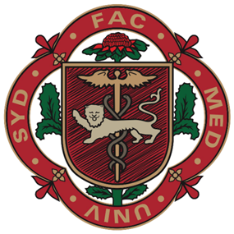
ENDORSERS
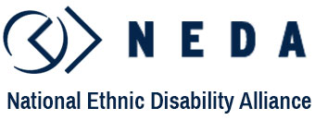
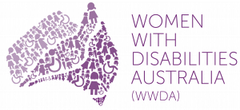
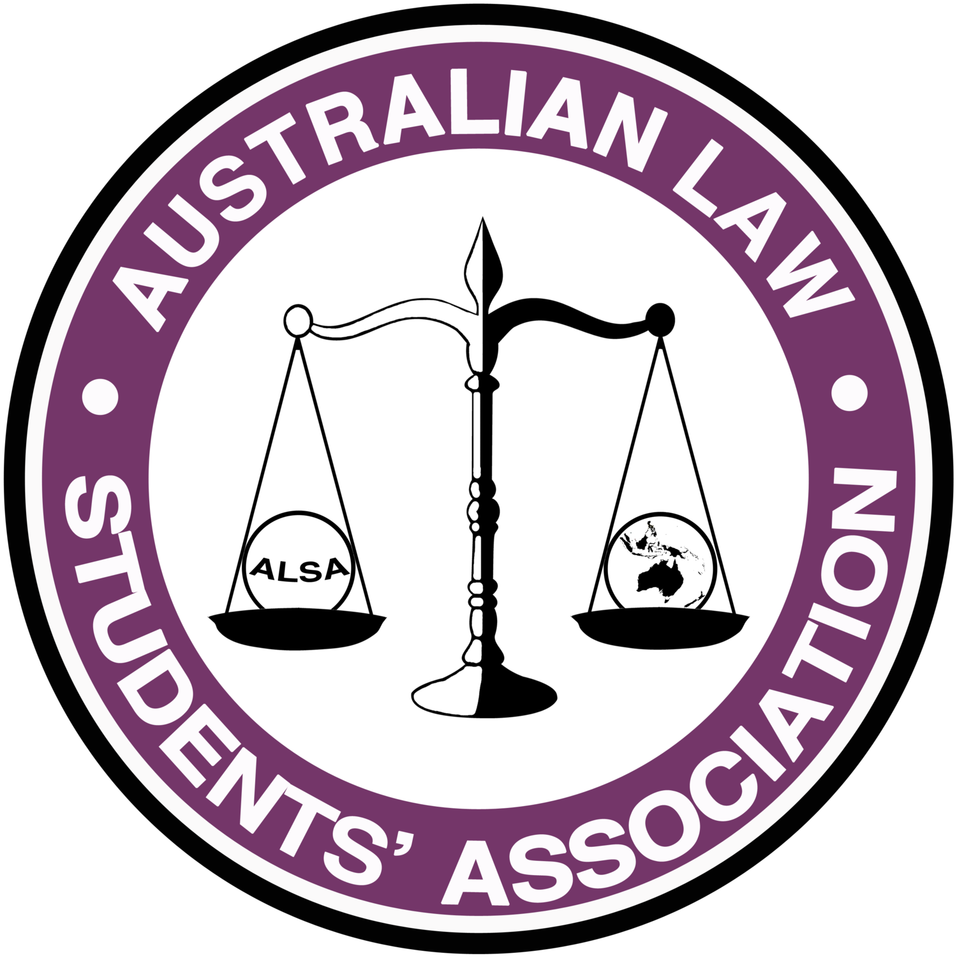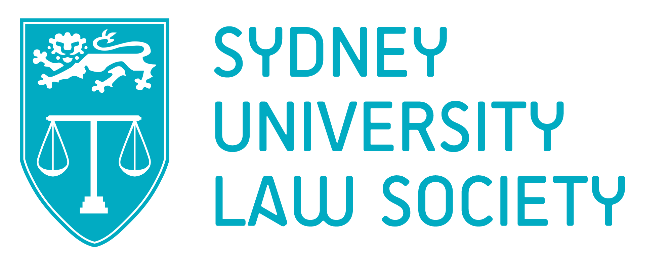

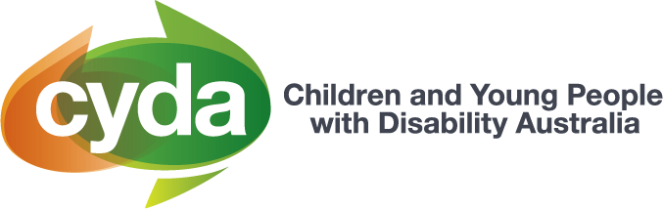

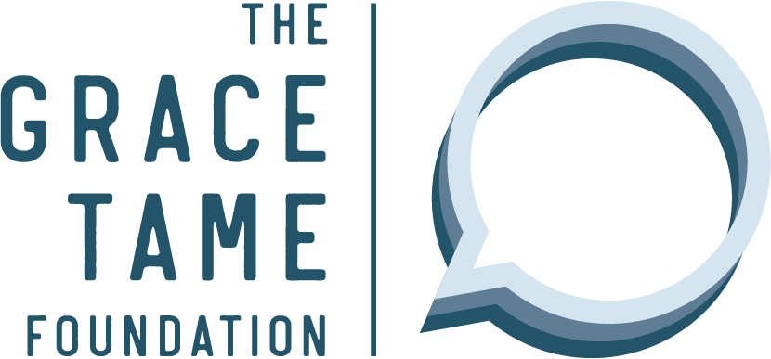
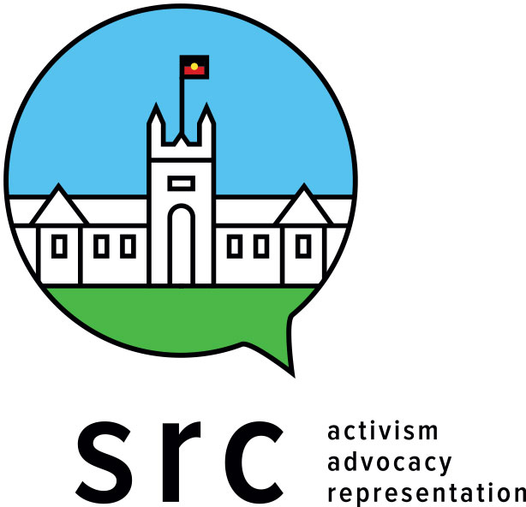
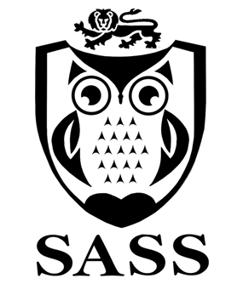

- National Union of Students (‘NUS’)
- Australian Law Students’ Association (‘ALSA’)
- Australian Medical Students’ Association (‘AMSA’)
- Sydney University Postgraduate Representative Association (‘SUPRA’)
- University of Sydney Students’ Representative Council (‘USYD SRC’)
- Sydney University Law Society (‘SULS’)
- Sydney University Medical Society (‘SUMS’)
- Sydney Arts Students’ Society (‘SASS’)
- Children and Young People with Disability Australia (‘CYDA’)
- National Ethnic Disability Alliance (‘NEDA’)
- Women With Disabilities Australia (‘WWDA’)
- First Peoples Disability Network (‘FPDN’)
- People With Disability Australia (‘PWDA’)
- Disabled People’s Organisations Australia (‘DPOA’)
- Australian Federation of Disability Organisations (‘AFDO’)
- Centre for Disability Research and Policy at the University of Sydney (‘CDRP’)
- Centre for Law and Social Justice at the University of Newcastle (‘CLSJ’)
- All Means All: Australian Alliance for Inclusive Education (‘All Means All’)
- Australian Coalition for Inclusive Education (‘ACIE’)
- Family Advocacy (NSW)
- Imagine More (ACT)
- Tasmanian Disability Education Reform Lobby (‘TDERL’)
- Community Resource Unit Ltd. (‘CRU’)
- JFA Purple Orange
- The HIV/AIDS Legal Centre (‘HALC’)
- People With Disability Western Australia (‘PWDWA’)
- ANU Disability Students’ Association (‘DSA’)
- Family Advocacy (NSW)
- Imagine More (ACT)
- The Antipoverty Centre
- The Grace Tame Foundation
- Grace Tame
- Dr Dinesh Palipana
- Dane Luo
- Dr Sheelagh Daniels-Mayes
- Dr Katherine Hepworth
- Rebecca Galdies
- Nicole Wedgewood
- Kylie Lunghusen
- Akii Ngo

Convention on the Rights of Persons with Disabilities, opened for signature 30 March 2007, 2515 UNTS 3 (entered into force 3 May 2008) (‘CRPD’).
Ibid arts 4(3), 5, and 33.
Ibid art 24.
Ibid art 24(5).
Ibid art 27.
Ibid art 5.
Ron McCallum, ‘The United Nations Convention on the Rights of Persons with Disabilities: An Assessment of Australia’s Level of Compliance’ (Research Report, Royal Commission into Violence, Abuse, Neglect and Exploitation of People with Disability, 8 October 2020), 14.
Sally Lindsay and Kristina Fuentes, ‘It Is Time to Address Ableism in Academia: A Systematic Review of the Experiences and Impact of Ableism among Faculty and Staff’ (2022) 2(2) Disabilities 128. See also Nicole Brown and Jennifer Leigh, ‘Ableism in academia: where are the disabled and ill academics?’ (2018) 33(6) Disability & Society 985.
Shane Pegg, Marion Karl and Paul Harpur, ‘Nothing about us unless it is led by us: Academics with Disabilities Driving Higher Education Reforms’ (2021) 24(14) Current Issues in Tourism 1945.
Damian Mellifont, ‘Ableist ivory towers: a narrative review informing about the lived experiences of neurodivergent staff in contemporary higher education’ (2021) (August) Disability & Society 1-22: 1-3.
See generally Shanna K Kattari, Miranda Olzman, Michele D Hanna, ‘“You Look Fine!”: Ableist Experiences by People With Invisible Disabilities’ (2018) 33(4) Affilia 477.
Australian Institute of Health and Welfare, People with disability in Australia 2022 (2022), 287.
Ibid 275-276.
Sue Kilpatrick et. al., ‘Exploring the retention and success of students with disability in Australian higher education’ (2017) 21(7) International Journal of Inclusive Education 2.
Australian Institute of Health and Welfare, People with disability in Australia 2022 (2022), 284.
Deanna Grant–Smith, Bernd Irmer and Robyn Mayes, ‘Equity in Postgraduate Education in Australia: Widening Participation or Widening the Gap?’ (Research Report, National Centre for Student Equity in Higher Education, 10 September 2020) 14.
Ibid, 31.
Damian Mellifont et al, ‘The ableism elephant in the academy: a study examining academia as informed by Australian scholars with lived experience’ (2019) 34(7-8) Disability & Society 1180. See also Vera L B Dolan ‘‘…but if you tell anyone, I’ll deny we ever met:’ the experiences of academics with invisible disabilities in the neoliberal university’ (2021) (February) International Journal of Qualitative Studies in Education 1-18: 1-5.
Deanna Grant–Smith, Bernd Irmer and Robyn Mayes, ‘Equity in Postgraduate Education in Australia: Widening Participation or Widening the Gap?’ (n 16) 6.
Ibid 6-7; 31.
Ibid 30-31.
Nom Kelk et al, ‘Courting the Blues: Attitudes towards depression in Australian law students and lawyers’ (Research Report, University of Sydney Brain & Mind Research Institute, 10 September 2020) 30.
Ibid 18.
Ibid 31.
Smeeta Singh & Anna Mountford-Zimdars, ‘Policy enactment in widening participation: enablers and barriers in a comparative English and Australian study’ (2016) 18(2) Widening Participating & Lifelong Learning 22, 44.
Deanna Grant–Smith, Bernd Irmer and Robyn Mayes, ‘Equity in Postgraduate Education in Australia: Widening Participation or Widening the Gap?’ (n 16) 31.
Ibid 34-35.
Doris Testa and Ronnie Egan, ‘Finding voice: The higher education experiences of students from diverse backgrounds’ (2014) 19(3) Teaching in Higher Education 229, 230.
See especially Sue Kilpatrick et. al., ‘Exploring the retention and success of students with disability in Australian higher education’ (n 14) 747.
Miriam Edwards et. al., ‘Academic accommodations for university students living with disability and the potential of universal design to address their needs’ (2022) (January) Higher Education 1-21, 14.
See, eg, Damian Mellifont, ‘A critical exploration of university policy supporting the employment and career development of people with disability in the Australian academy’ (2020) 29(2) Australian Journal of Career Development 117, 117-120; Tim Pitman et. al., ‘Three decades of misrecognition: defining people with disability in Australian higher education policy’ (2021) (July) Disability & Society 1-16.
Elizabeth Dickson, ‘Disability Standards For Education 2005 (Cth): Sword Or Shield For Australian Students With Disability?’ (2014) 19(1) International Journal of Law & Education 5, 11.
Ibid 7.
Ibid. See also Sievwright v State of Victoria [2012] FCA 118 (‘Sievwright’); Walker v State of Victoria (2011) 279 ALR 284 (‘Walker’).
Ibid. See also Anabel Moriña & Inmaculada Orozco, ‘Planning and implementing actions for students with disabilities: Recommendations from faculty members who engage in inclusive pedagogy’ (2020) 103 International Journal of Educational Research 101639.
See especially Adrienne Doebrich, Marion Quirici, & Christopher Lunsford, ‘COVID-19’s Impact on the Practice of Pediatric Rehabilitation Medicine: Insights and Recommendations’ (2020) 13(3) Journal of Pediatric Rehabilitation Medicine 393, 393-401. See also Damian Mellifont et al, ‘The ableism elephant in the academy: a study examining academia as informed by Australian scholars with lived experience’ (n 18) 1184-1190.
Michelle M Ralston, ‘Translating the Disability Standards for Education 2005 Into Practice’ (Doctoral Thesis, University of Newcastle, 2022) 306.
Paul Koshy et al, ‘Discussion Paper on the 2020 Review of the Disability Standards for Education 2005’ (Research Fellowship Final Report, National Centre for Student Equity in Higher Education, 25 September 2022) <https://www.ncsehe.edu.au/wp-content/uploads/2020/09/NCSEHE_Discussion-Paper_DSE-Review_FINAL_23092020-FINAL.pdf>.
Miriam Edwards et. al., ‘Academic accommodations for university students living with disability and the potential of universal design to address their needs’ (n 30) 14.
Ibid 4. See also Nicole Brown and Karen Ramlackhan, ‘Exploring experiences of ableism in academia: a constructivist inquiry’ (2022) 83 Higher Education 1225-1239.
See, eg, Children and Young People with Disability Australia (‘CYDA’), Submission to Royal Commission into Violence, Abuse, Neglect and Exploitation of People with Disability (16 October 2020).
Ibid.
See Australian Institute of Health and Welfare, People with disability in Australia 2022 (2022), 162-184.
‘Disability Community Calls For Reform After Discrimination Claims Become ‘Impossible To Prove’’, Australian Lawyers for Human Rights, (Media Release / Web Page, 3 July) 68 <https://alhr.org.au/calls-for-reform-after-discrimination-claims>.
(2017) 256 FCR 247; [2017] FCAFC 128 (‘Sklavos’).
Alice Taylor, ‘Disability Discrimination, the Duty to Make Adjustments and the Problem of Persistent Misreading’ (2020) 45(2) Monash University Law Review 461, 475.
Sklavos (n 45) [23]-[25].
Alice Taylor, ‘Disability Discrimination, the Duty to Make Adjustments and the Problem of Persistent Misreading’ (n 46) 462.
See generally Disability Discrimination Legal Service (‘DDLS’), Submission to Australian Human Rights Commission, Free and Equal: Priorities for federal discrimination law reform (November 2020) 23-25.
Ibid 24. See also Douglas C Baynton, ‘‘These Pushful Days’: Time and Disability in the Age of Eugenics’ (2011) 13(2) Australian and New Zealand Society of the History of Medicine 43.
DDLS, Submission No 153 to Senate Select Committee on Autism, Parliament of Australia, Inquiry into Services, Support and Life Outcomes for Autistic Australians [41].
Ibid [29]-[41].
(2003) 217 CLR 92 (‘Purvis’).
[2018] FCA 1655 (‘Varasdi’).
[2012] FCA 118 (‘Sievwright’). See also Walker v State of Victoria (2011) 279 ALR 284 (‘Walker’).
Chung v University of Sydney [2002] FCA 186 (‘Chung’).
Alice Taylor, ‘Disability Discrimination, the Duty to Make Adjustments and the Problem of Persistent Misreading’ (n 46) 472. See also Jacob Campbell, ‘Using Anti-discrimination Law as a Tool of Exclusion: A Critical Analysis of the Disability Discrimination Act 1992 and Purvis v NSW’ (2005) 5 Macquarie Law Journal 201, 220.
See Anna Lawson, Disability and Equality Law in Britain: The Role of Reasonable Adjustment (Hart Publishing, 2008) 11.
Alice Taylor, ‘Disability Discrimination, the Duty to Make Adjustments and the Problem of Persistent Misreading’ (n 46) 486.
Ibid 462, citing Archibald v Fife Council [2004] 4 All ER 303; British Columbia (Public Service Employee Relations Commission) v British Columbia Government Service Employees’ Union [1999] 3 SCR 3.
PwC, ‘Disability Expectations: Investing in a Better Life, A Stronger Australia’, (Report prepared for the Productivity Commission, PwC, November 2011) <https://www.pwc.com.au/industry/government/assets/disability-in-australia.pdf>.
See especially Ron McCallum, ‘The United Nations Convention on the Rights of Persons with Disabilities: An Assessment of Australia’s Level of Compliance’ (n 7), 16-21; 81-82.
See generally Fleur Beaupert, Linda Steele & Piers Gooding, ‘Introduction to disability, rights and law reform in Australia: Pushing beyond legal futures’ (2017) 35(2) Law in Context 1.
Elizabeth Dickinson, ‘Understanding Disability: An Analysis of the Influence of the Social Model of Disability in the Drafting of the Anti-Discrimination Act 1991 (Qld) and in its Interpretation and Application’ (2013) 8(1) Australia & New Zealand Journal of Law & Education 47, 52-53, quoting Brackenreg v Queensland University of Technology [1999] QADT 1 (‘Brackenreg’).
See Department of Education, Skills and Employment, Final Report of the 2020 Review of the Disability Standards for Education 2005 (Final Report, March 2021) 44-45.
Lucy Mercer-Mapstone et al, ‘Recommendations for equitable student support during disruptions to the higher education sector: Lessons from COVID-19’ (Research Report, National Centre for Student Equity in Higher Education, 8 March 2022) <https://www.ncsehe.edu.au/wp-content/uploads/2022/03/Mercer-Mapstone_USYD_Final.pdf>.
Michelle Villeneuve, ‘Clearing a path to full inclusion of people with disability in emergency management policy and practice in Australia’ (Issues Paper, Centre for Disability Research and Policy, The University of Sydney, 1 July 2021). See also David Alexander. ‘Disability and Disaster: An Overview’ in Ilan Kelman and Laura Stough (eds), Disability and Disaster: Explorations and Exchanges (Palgrave Macmillan, London, 2015) 15–29.
Royal Commission into Violence, Abuse, Neglect and Exploitation of People with Disability, Overview of responses to the Emergency planning and response Issues paper (Overview of Responses Paper, February 2021) 7.
Linda Steele, ‘Lawful Institutional Violence Against Disabled People’ (2017) 143 (November/December) Precedent 4.
Dale Dominey-Howes, Andrew Gorman-Murray, Andrew and Scott McKinnon, ‘Queering disasters: on the need to account for LGBTI experiences in natural disaster contexts’ (2014) 21(7) Gender, Place & Culture 905.
Lucy Mercer-Mapstone et al, ‘Recommendations for equitable student support during disruptions to the higher education sector: Lessons from COVID-19’ (n 66) 14.
Ibid 9.
Ibid 108.
Ibid 107.
Ibid 70. See also Matthew Capp, ‘The effectiveness of university design for learning: a meta-analysis of literature between 2013 and 2016’ (2017) 21(8) International Journal of Inclusive Education 791.
Tim Pitman, ‘Supporting persons with disabilities to succeed in higher education’ (Research Fellowship Final Report, National Centre for Student Equity in Higher Education, 8 March 2022) <https://www.ncsehe.edu.au/wp-content/uploads/2022/03/Pitman_Curtin_EquityFellowship_FINAL.pdf>.
Ibid 14.
Ibid 50.
Kinsela v Queensland University of Technology [1997] HREOC No H97/4. Cf Sluggett v Flinders University of South Australia [2000] HREOC No H96/2.
Juuso Henrik Nieminen and Henri Valtteri Pesonen, ‘Taking universal design back to its roots: Perspectives on accessibility and identity in undergraduate mathematics’ (2020) 10(1) Education Sciences 12.
See especially Tim Pitman, ‘Supporting persons with disabilities to succeed in higher education’ (n 76) 57.
See, eg, Ira Magaziner and Elliot Maxwell, ‘The Magaziner-Maxwell Report (Draft of a Working Paper for Education at Brown University): the seed of a curricular revolution at Brown’ (Working Paper, First Open Jar Edition, Open Jar Foundation, October, 2011) <https://library.brown.edu/libweb/papers/BrownCurriculum.pdf>; Katherine Bergeron, ‘Case study: A tradition of reform: The curriculum at Brown University’ in Paul Blackmore & Camille B Kandiko (eds), Strategic Curriculum Change in Universities (Routledge, 2012) 32.
Asanda Ngoasheng et al, ‘Advancing democratic values in higher education through open curriculum co‑creation’ in Lynn Quinn (ed), Re-imagining Curriculum: Spaces for disruption (SUN PReSS, 2019) 327. See also Tanya Lubicz-Nawrocka and John Owen, ‘Curriculum Co-creation in a Postdigital World: Advancing Networked Learning and Engagement’ (2022) 4(2) Postdigital Science and Education 793.
Amanda Roberts et al, ‘‘Standing up for my human rights’: a group’s journey beyond consultation towards co-production’ (2012) 40(4) British Journal of Learning Disabilities 292. See also Asam Latif et al, ‘Giving Voice to the Medically Under-Served: A Qualitative Co-Production Approach to Explore Patient Medicine Experiences and Improve Services to Marginalized Communities’ (2018) 6(1) Pharmacy 13.
Ibid.
See generally Peter Williams et al, ‘Fit for purpose: traditional assessment is failing undergraduates with learning difficulties. Might eAssessment help?’ (2014) 18(6) International Journal of Inclusive Education 614. See also Damian Mellifont, ‘A critical exploration of university policy supporting the employment and career development of people with disability in the Australian academy’ (n 31) 118-120.
Joanna Tai et al, ‘How are examinations inclusive for students with disabilities in higher education? A sociomaterial analysis’ (2022) (May) Assessment & Evaluation in Higher Education 1-14: 10-11.
Lucy Mercer-Mapstone et al, ‘Recommendations for equitable student support during disruptions to the higher education sector: Lessons from COVID-19’ (n 66) 75.
Lucy Mercer-Mapstone et al, ‘Recommendations for equitable student support during disruptions to the higher education sector: Lessons from COVID-19’ (n 66) 79.
Lucy Mercer-Mapstone et al, ‘Recommendations for equitable student support during disruptions to the higher education sector: Lessons from COVID-19’ (n 66) 75-76.
Autism Queensland, Submission No 129 to Senate Select Committee on Autism, Parliament of Australia, Inquiry into Services, Support and Life Outcomes for Autistic Australians 21.
Untapped Holdings Pty Ltd, Submission No 92 to Senate Select Committee on Autism, Parliament of Australia, Inquiry into Services, Support and Life Outcomes for Autistic Australians 1. See also Australian Autism Alliance, Submission No 529 to Senate Select Committee on Autism, Parliament of Australia, Inquiry into Services, Support and Life Outcomes for Autistic Australians 9.
Ye In Jane Hwang et al, ‘Mortality and cause of death of Australians on the autism spectrum’ (2019) 12(5) Autism Research 806, 806-807.
See also Varasdi, Sievwright, Walker, and Chung.
Elizabeth Dickinson, ‘Understanding Disability: An Analysis of the Influence of the Social Model of Disability in the Drafting of the Anti-Discrimination Act 1991 (Qld) and in its Interpretation and Application’ (2013) 8(1) Australia & New Zealand Journal of Law & Education 47, 53.
See generally Paul Harpur, ‘Sexism and racism, why not ableism? Calling for a cultural shift in the approach to disability discrimination’ (2009) 34(3) Alternative Law Journal 163.
See especially Tim Pitman, ‘Supporting persons with disabilities to succeed in higher education’ (n 76) 57.
Ibid 2.
See especially Adrienne Doebrich, Marion Quirici, & Christopher Lunsford, ‘COVID-19’s Impact on the Practice of Pediatric Rehabilitation Medicine: Insights and Recommendations’ (n 36) 393-401.
Universities Australia, 2018, 2017 University Australia Student Finances Survey. Melbourne Centre for the Study of Higher Education, ‘2017 University Australia Student Finances Survey’, (Report prepared for Universities Australia, Melbourne Centre for the Study of Higher Education, August 2018) 11.
Ibid 3.
Australian Institute of Health and Welfare, People with disability in Australia 2022 (2022), 385.
See generally Senate Community Affairs References Committee, Parliament of Australia, Purpose, intent and adequacy of the Disability Support Pension (2022) [1.52]. Note that under s 94 of the Social Security Act 1992 (Cth), applicants for the DSP must demonstrate that they can work less than 15 hours per week before they are granted the DSP and the authorisation to work up to 30 hours per week.
Ibid.
Ibid.
Australian Institute of Health and Welfare, People with disability in Australia 2022 (2022), 389.
Ibid 393. See also Senate Community Affairs References Committee, Parliament of Australia, Purpose, intent and adequacy of the Disability Support Pension (2022) [2.108]-[2.112].
Senate Community Affairs References Committee, Parliament of Australia, Purpose, intent and adequacy of the Disability Support Pension (2022) [2.109].
Senate Select Committee on Autism, Parliament of Australia, Services, support and life outcomes for autistic Australians (2022) [3.2].
Ibid [12.183].
Ibid [12.180].
Ibid [12.181] - [12.187].
Royal Commission into Violence, Abuse, Neglect and Exploitation of People with Disability, Nature and extent of violence, abuse, neglect and exploitation against people with disability in Australia (Research Report Project 8, March 2021) 9-10.
Ibid.
Australian Human Rights Commission, Change the Course: National Report on Sexual Assualt and Sexual Harassment on campus (Report, August 2017).
Tertiary Education Quality and Standards Agency, TEQSA Compliance Report 2021 (Report, March 22).
See, eg, ‘Register of Disability Discrimination Act Action Plans’, Australian Human Rights Commission (Web Page, 17 July 2022) <https://humanrights.gov.au/our-work/disability-rights/register-disability-discrimination-act-action-plans>. See also ‘Disability action plan’, Tertiary Education Quality and Standards Agency (Web Page, 2 July 2019) <https://www.teqsa.gov.au/latest-news/publications/disability-action-plan>.
See ‘Where can I get further help?’, Australian Qualifications Framework (Web Page, 17 July 2022) <https://www.aqf.edu.au/help-qualifications/where-can-i-get-further-help>. See also ‘Providing quality training and assessment services to students with disabilities’, Australian Skills Quality Authority (Web Page, 12 May 2016) <https://www.asqa.gov.au/resources/fact-sheets/providing-quality-training-and-assessment-services-to-students-with-disabilities>. Cf ‘Easy Read’, Australian Government Style Manual (Web Page, 6 September 2021) <https://www.stylemanual.gov.au/content-types/easy-read>.
‘Transcript of Proceedings’, Royal Commission into Violence, Abuse, Neglect and Exploitation of People with Disability (Web Page, 29 March 2022) <https://disability.royalcommission.gov.au/system/files/2022-04/Transcript%20Day%202%20-%20Public%20hearing%2017%20%28Part%202%29%2C%20Hobart_1.pdf>.
KPMG, ‘The Cost of Violence against Women and their Children in Australia: Final Detailed Report’, (Report prepared for the Department of Social Services, KPMG, May 2016) 68 <https://www.dss.gov.au/sites/default/files/documents/08_2016/the_cost_of_violence_against_women_and_their_children_in_australia_-_final_report_may_2016.pdf>.
William Leonard and Rosemary Mann, ‘The everyday experience of lesbian, gay, bisexual, transgender and intersex (LGBTI) people living with disablity’ (Research Paper No.111, GLHV@ARCSHS, La Trobe University, July 2018); ‘Alarming rates of family, domestic and sexual violence of women and girls with disability to be examined in hearing’, Royal Commission into Violence, Abuse, Neglect and Exploitation of People with Disability (Web Page, 12 October 2021) <https://disability.royalcommission.gov.au/news-and-media/media-releases/alarming-rates-family-domestic-and-sexual-violence-women-and-girls-disability-be-examined-hearing>.
See generally Michelle M Ralston, Submission to the Australian Department of Education, 2020 Review of the Disability Standards for Education 2005 (12 March 2021) 7-8 <https://www.dese.gov.au/system/files/documents/submission-file/2021-02/Submission%20-%20Ralston%2C%20Michelle.pdf>.
The Committee on the Rights of Persons with Disabilities, Concluding Observations on the Second and Third Combined Reports of Australia, 22nd sess, UN Doc CRPD/C/AUS/CO/2-3, 15 October 2019 [12].
Ibid. See also Ilias Bantekas, ‘Article 7 Children With Disabilities’, in Ilias Bantekas, Michael Ashley Stein and Dimitris Anastasiou (eds), The UN Convention on the Rights of Persons with Disabilities: A Commentary (Oxford University Press, 2018) 198.
Ron McCallum, ‘The United Nations Convention on the Rights of Persons with Disabilities: An Assessment of Australia’s Level of Compliance’ (n 7), 23-24. See also The Committee on the Rights of Persons with Disabilities, Concluding Observations on the Second and Third Combined Reports of Australia, 22nd sess, UN Doc CRPD/C/AUS/CO/2-3, 15 October 2019 [12](b).
Ibid.
Department of Education, Skills and Employment, Final Report of the 2020 Review of the Disability Standards for Education 2005 (Final Report, March 2021) 47. See also Paul Koshy et al, ‘Discussion Paper on the 2020 Review of the Disability Standards for Education 2005’ (n 38) 5.

